May 21, 1984
Mr. Antonio Caetano GM Componentes
Cadiz, Spain ,
Dear Antonio,
I am indeed sorry to learn that you will be leaving General Motors, but sincerely pleased to know that you will be moving forward to an excellent professional opportunity.
You have done an excellent job, in so many ways, for General Motors in Cadiz, and your work and contributions are very mauch appreciated. You have brought a professional background and ability that was much needed at GM Componentes, and you have always done your assigned jobs with diligence and skill. You have often contributed good counsel and assistance to the management, well beyond the requirements of your job, and you have done a superb job of representing General Motors and advancing our interests with the officials and news media of your area.
Personally, I consider you to be a valued friend and a man of outstanding character and talent. I know that we will continue to stay in contact, and I will want to see you whenever we can get together in the future. Be sure to let me know if I can ever be of help in any way.
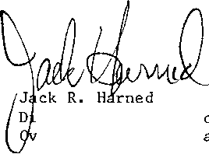Antonio, you have my sincere best wishes for every success and happiness in the future. You may, of course, use my name and this letter as a reference if you wish.
Sincerely,
rector, International Programs erseas Public Relations
msg:
General Motors Building 3044 West Grand Boulevard Detroit, Michigan 48202
May 21, 1984
Mr. Peter Bicknell
Public Relations Director
Citibank
336 The Strand
London WC2R 1HB
England
Dear Peter,
I'm really quite chagrined to learn that your bank has pinched one of our best young public relations men. Antonio Caetano tells me he is leaving the GM operation at Cádiz, Spain, to join your Spanish bank in Madrid. -
You're getting a very good man. Antonio has done a conscientious and effective professional job for GM in the sometimes-difficult circumstances of starting up a new plant. And personally, I've found him to be a man of excellent character and a valued friend. We're sorry to lose him, but pleased that he will have a good oppportunity with another good organization.
You may know that GM has requested my future services in Detroit, at our Corporate headquarters. I’ll still be in intemational public relations, but I will miss our PR Roundtable meetings. It was always a pleasure to be with you and our congenial colleagues, and I do hope you'll cali me if you ever happen to be in Detroit...or if there's anything I can do for you here. .
Best regards,
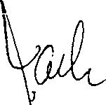

Jack R. Harned director, International Programs Overseas Public Relations
msg:
cc: Mr. A. Caetano
Genera) Motors Building 3044 West Grand Boulevard Detroit, Michigan 46202
General Motors España

MEMORANDUM PARA USO INTERNO
A: F . Kowalski
N.°:
Teléfono:
De:Javier Oraa

Fecha: April 1, 1981
Asunto:
I had a most interesting meeting yesterday with Mr. Caetano and I would like to congratúlate you and your Staff for the choice you have made not only with the job he is accomplish- ' ing now with your personnel but as the Public Relations man . for your Plants.
We were both in agreement on the approach of Public Relations attitude and I reviewed with him the preliminary plans he submitted to you and in my opinion, you should start as soon as possible and you may be assured, you will have a full back- i ng.
I have already given instructions to send you copies of our press releases and I am convinced that from now on Mr. Cae- taño will be able to coordinate múch better our general Public Affairs Relations in Spain with the local ones that affect more directly to you.
As discussed in the Country Meeting, I am still planning to make a trip to Cádiz and if you agree, I will suggest we plan it for mid-May, right after the Barcelona Automobile Show, but before the car test program that we are preparing for the second part of Hay.
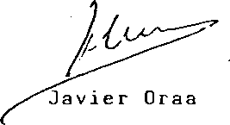At this time, I agree with him on the idea of having a press visit to the Plant, and lunch or dinner, with a small group of Journalists from the area as suggestéd. Mr. Caetano plan- ned for May 6th, but I have proposed him to pospone it be- cause the Automobil S h¿) w will be still open on that day and I think he should attend it and most Journalists will be there until the lOth. •
JO/Abr
cc: Mr. RCNerod , Mr. AMoreno [

